Product specifications, user manuals and

certifications coming to this link soon.

Thanks for looking!

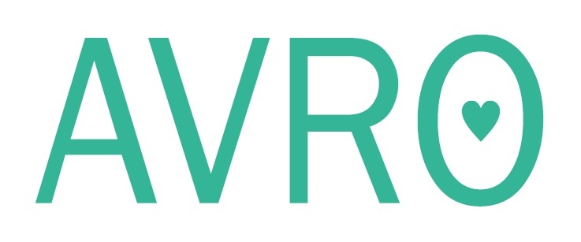

Avro Health Ltd

105 London Street

Reading, RG1 4QD

United Kingdom

[info@avro.health](mailto:info@avro.health)

+44 (0)20 3633 5485

+44 (0)7500 897161